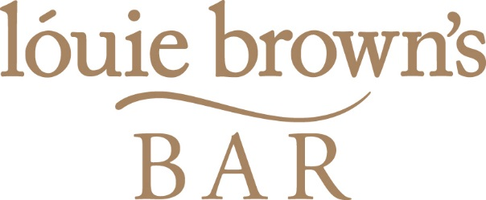
Finger Buffet Selector
4 items £10.95pp 5 items £12.95pp 6 items £14.95pp 7 items £16.95pp

Selection of Sandwiches | Seasoned Wedges (v)
Sweet Chilli Chicken Strips | Tempura Battered King Prawns
Breaded Brie & Cranberry (v) | Vegetable Spring Rolls (v)
Haggis/Veggie Haggis Fritters (v)  Sausage/Veggie Sausage Rolls (v)  Mozzarella Sticks (v) | Mini Millionaire Shortbread (v)  Strawberries Dipped in Chocolate (v)  Mini Chocolate Eclairs (v)  Selection of Sweet Mini Pastries (v)

Hot Pot Buffet Selector
£10.95 per person – Choose 1 option
£18.95 per person – Choose 2 options
(Minimum number – 20 people)
Chicken or Vegetarian Curry with Rice (v) | Scottish Stovies
Beef or Vegetarian Chilli with Rice (v) | Selection of Pizzas (Margherita, Pepperoni, Meat Feast, Veggie) (v)
Regular or Vegetarian Haggis with Neeps & Tatties (v) | Sausages, Mash & Onion Gravy

Tea or Coffee with Shortbread
£2.60 per person

