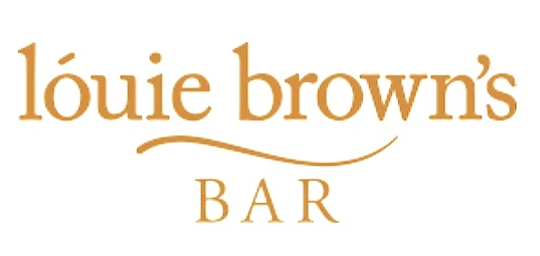
We are excited to welcome you back!
Ensuring the health and safety of our customers and our team is our main priority, we have conducted extensive deep cleaning of our venue prior to opening and have added to our already comprehensive hygiene routines.
Please read the guidance below before your visit with us.
- We have hand sanitizing points located throughout our building
- QR codes will be on every table and we ask that you scan with your mobile phone
and enter your details. All information will be held securely and compliantly with GDPR
- We have protective screens placed around our bar
- There will be regular sanitization of all surfaces, toilets and contact points
- Temperature checks will be carried out for all staff prior to starting work
- You will be allocated a table and it will be table service only at the moment
- We have laminated menus that are sanitised after every use
- All tables and condiments are thoroughly cleaned and sanitised between guests
- Staff hand washing is carried out every 10 minutes or before if required.
- We are a family friendly environment, however if you are bringing children they will need to remain seated.
- We will constantly review all processes and procedures in line with any new Scottish government guidelines
- We ask that you please be respectful to our team and to other guests
- Socialise Responsibly

