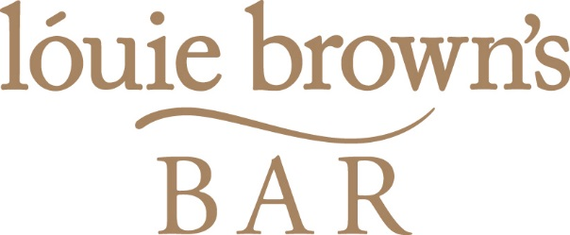

KIDS MENU

All kids meals are £4.95

Fresh Haddock Goujons
Chicken Breast Goujons
Louie Brown’s Sausages
Mini Steak Burger
All served with chips or mashed potato and salad, beans or veg
Pasta – Cheese or Tomato

Includes ice cream with chocolate or strawberry sauce

